**Addition of two 16bit numbers**

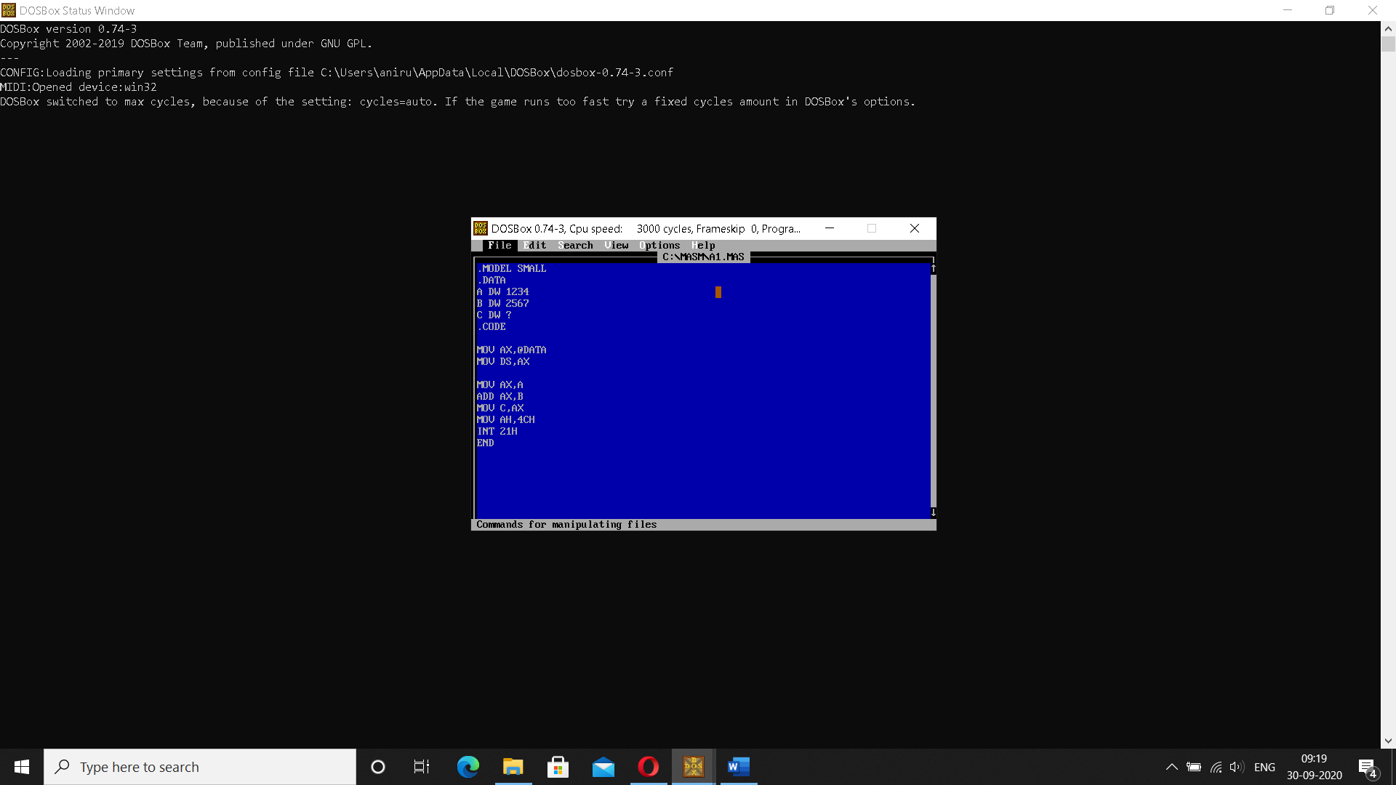

**Addition of two 8 bit numbers**

